**Q.) Write a program to implement "Shortest Job First" Scheduling Algorithm.**

Ans.)

#!/usr/bin/env python

from sys import exit

def main():

process_que = []

burst_time = []

waiting_time = []

turn_around = []

total_processes = input("Enter Total Number of Processes : ")

if total_processes == 0:

print("You need to enter at least 1 process to Schedule.")

exit()

elif total_processes != 0:

for i in range(int(total_processes)):

process_que.append(input("Enter Process Name : "))

burst_time.append(input("Enter Process Burst Time : "))

keydict = dict(zip(process_que, burst_time))

process_que.sort(key=keydict.get)

burst_time.sort()

for i in range(int(total_processes)):

if i == 0:

waiting_time.insert(0, 0)

waitingCalculator = int(burst_time[i]) + int(waiting_time[i])

waiting_time.insert(i + 1, waitingCalculator)

turnaroundCalculator = int(burst_time[i]) + int(waiting_time[i])

turn_around.insert(i, turnaroundCalculator)

waiting_time.pop()

print("Process Name\t| Burst Time\t| Waiting Time\t| Turn Around Time")

print('-' * 60)

for x, y, z, k in zip(process_que, burst_time, waiting_time, turn_around):

print(str(x) + ' \t\t\t\t|', str(y) + ' \t\t\t|', str(z) + ' \t\t\t|', str(k))

print('\n');

print('-' * 60)

print("Average Waiting Time : %s" % (sum(waiting_time) / len(waiting_time)))

print("Average Turn Around Time : %s" % (sum(turn_around) / len(turn_around)))

print('-' * 60)

if __name__ == '__main__':

main()

**Output :**

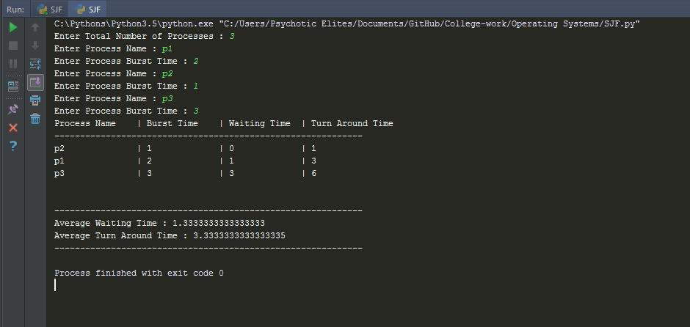

**Shortest Job First Scheduling**